Name___________________________________ Period_______

Artificial Selection Lab – "Born to Run" In the box below, draw a hypothetical organism that is an excellent runner. Remember that this is independent work. You will get a chance to compare your drawings later!

Now compare your drawing with those by other members of your team.
List the common features on the lines below.

- ___________________________________________
- ___________________________________________
- ___________________________________________
- ___________________________________________
- ___________________________________________
- ___________________________________________
- ___________________________________________
- ___________________________________________

Write a paragraph to explain how natural selection might act on a population of organisms that varied in the traits you listed.

_______________________________________________________________________________________________________________________________________________________________________________________________________________________________________________________________________________________________________________________________________________________________________________________________________________________________________________________________________________________________________________________________________________________________________________________

Name___________________________________ Period_______

Artificial Selection Lab – Automated Measurements

A. How might legs change in a way that would improve the ability for wheel running? In other words, what leg adaptations might evolve? Discuss with your lab partner and then circle the one you will choose to study.
_____________________________ _________________________
_____________________________ _________________________
_____________________________ _________________________

B. You will have available digital photographs femurs of mice to take measurements. Write the question you have chosen to investigate regarding femur dimensions:

Are the femurs of mice selectively bred for wheel running _____________________?

C. What will you measure on a femur bone to find the answer for your question?
_____________________________

Hypothesis: Write your hypothesis and be sure to use the if... then... format and include an explanation.
_______________________________________________________________________________________________________________________________________________________________________________________
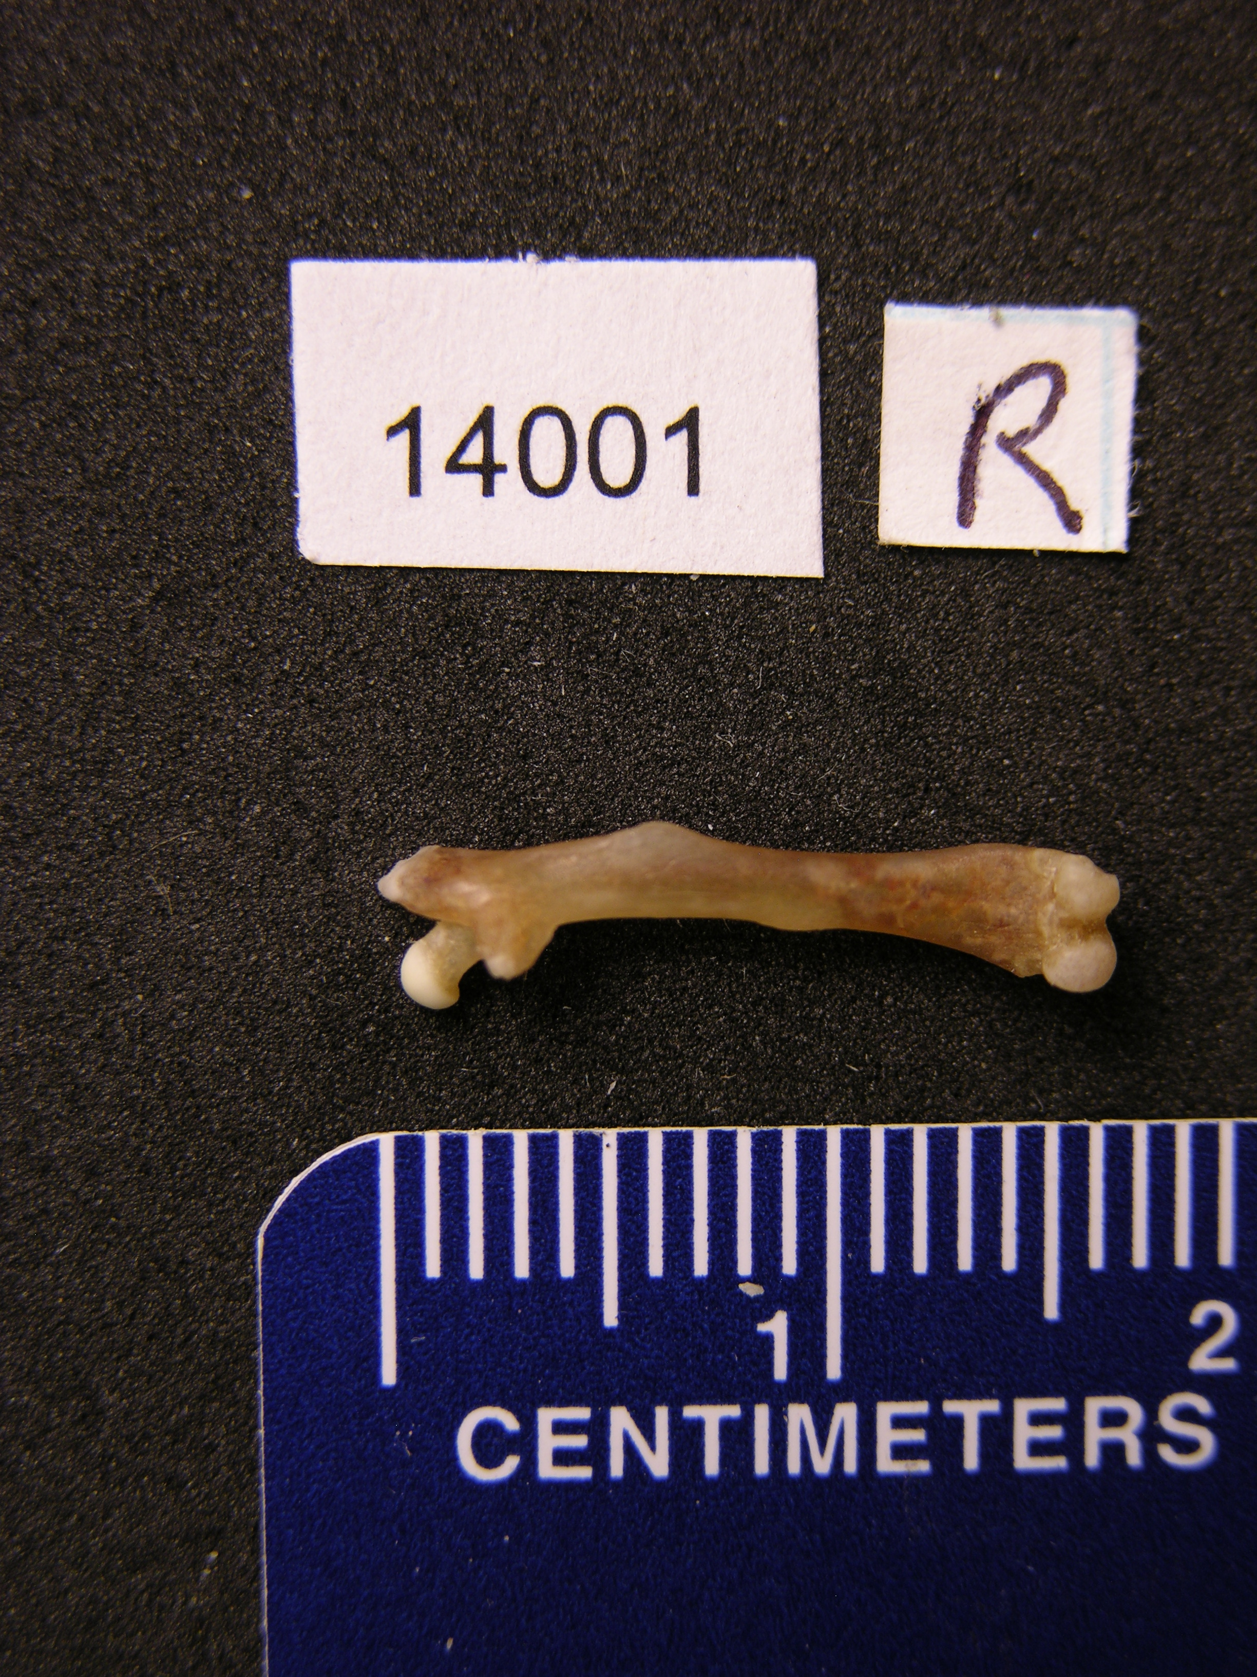
C. Method: With your lab partner, decide how you will measure the femurs of the control and selected lines of mice. Draw a line on the photograph that shows where you will measure. Be sure to be consistent with each photograph you measure.

The mice, from generation 11 of the selection experiment, have been studied previously, as reported in this paper:
Garland, T., Jr., and P. A. Freeman. 2005. Selective breeding for high endurance running increases hindlimb symmetry. Evolution 59:1851-1854.
You will be measuring the same bones they used.

Using Image J to measure bone (femur) lengths: Student Directions

- File – open: Select image
- Select line tool on the tool bar
- Draw line on the ruler that is 15 mm long (1.5 cm)
- Analyze – set scale
- Enter 15 in “Known scale” and mm in “Unit of length”. You can choose to display in mm also and set the number of decimals of accuracy.
- Click “Global” This will apply the scale measurement to each picture that you measure thereafter.
- Draw a line at the dimension which will be measured. The scale bar will display the measurement as well as the angle of the line. This will disappear when you click the end point of the line.
- Analyze-measure: A data table will appear with the first measurement
- File – open next : The next image to be measured appears
- Draw a new line on the new femur picture.
- Analyze – measure: The next length will be displayed on the data table
- When your measurements are complete, select Analyze – summarize.
- Record the average from the displayed information. You will be graphing these data later.
- Repeat steps 1-13 for the control animals.
16 Folders are on the Flash Drive:
G12_Control_L1_Female_Femora
G12_Control_L2_Female_Femora
G12_Control_L4_Female_Femora
G12_Control_L5_Female_Femora

G12_Control_L1_Male_Femora
G12_Control_L2_Male_Femora
G12_Control_L4_Male_Femora
G12_Control_L5_Male_Femora

G12_Selected_L3_Female_Femora
G12_Selected_L6_Female_Femora
G12_Selected_L7_Female_Femora
G12_Selected_L8_Female_Femora

G12_Selected_L3_Male_Femora
G12_Selected_L6_Male_Femora
G12_Selected_L7_Male_Femora
G12_Selected_L8_Male_Femora

Each folder contains photos of left and right femurs of several individual mice (although in a few cases one or the other is missing).

The above folders are also available by clicking here:
http://www.biology.ucr.edu/people/faculty/Garland/G12_Split_for_STEM/
Name___________________________________ Period_______

Results

Sample number | Selected Measurement (cm) | Sample number | Control Measurement (cm)
Averages

 | Average Measurement (mm) | Total number of femurs measured
Selected

Controls

Conclusion

Write a concluding paragraph. Use additional paper if necessary.
- What effect did selecting for the trait of wheel running have on the femurs of the selected and control mice?
- Explain how the average femur measurements for selected and control mice support your inference. Be sure to restate the averages you obtained.
- Was your hypothesis supported or not?
- What parts of your method might have resulted in inaccuracies?
- Suggest further questions to address.

_______________________________________________________________________________________________________________________________________________________________________________________________________________________________________________________________________________________________________________________________________________________________________________________________________________________________________________________________________________________________________________________________________________________________________________________________________________________________________________________________________________________________________________________________________________________________________________________________________________________________________________________________________________________________________________________________________________________________________________________________________________________________________________________________________________________________________________________________________________________________________________________________________________________________________________________________

