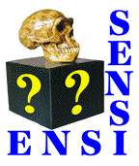 | Born to Run:  Artificial Selection Lab  by Theodore Garland, Jr., Ph.D.  (University of California, Riverside)  and Tricia Radojcic, Ph.D.  (Bella Vista Middle School, Murrieta, California) | EVOLUTION: Variation and Natural Selection  Two versions of this lesson have been tested with 7th grade students by the second author, and it has been used twice at the Riverside  STEM academy.

SYNOPSIS
Students are introduced to the field of experimental evolution by evaluating skeletal changes in mice that have been artificially selected over many generations for the behavioral trait of voluntary exercise wheel running. A video presentation by Dr. Theodore Garland, Jr. of the University of California, Riverside discusses the experimental design and presents the results of the collaborative research on the structural, metabolic, and neural changes in the selected lines of mice. In an inquiry-based activity, students develop hypotheses about the skeletal changes that might occur in the legs of the selected mouse populations and design an investigation using measurements taken from photographed femurs (thigh bones) of mice from both selected lines and non-selected control lines.
PRINCIPAL CONCEPT
Experimental evolution allows the processes of evolution to be modeled and observed in the laboratory with real organisms.
ASSOCIATED CONCEPTS
1. A population of animals can be changed dramatically by selective breeding over successive generations.
2. Selective breeding for a behavioral trait also causes changes in neurobiology, body structures (e.g., limb bones), metabolism, and biochemistry.
3. Variation in behavioral traits and any other associated biological traits can be passed on from parents to their offspring.

ASSESSABLE OBJECTIVES Students will....
1. relate the structure of a bone to its role in locomotion
2. identify structural adaptations that may facilitate running
3. develop and explain testable hypotheses about the structural features of femurs that might be adaptations in animals experimentally evolved for wheel running
4. perform consistent, reproducible measurements on samples
5. formulate and explain a conclusion based on collected data

MATERIALS (Teacher prep)
1. Born to Run: Artificial Selection Lab Teacher Information.
2. Video (1.5 GB) of Dr. Theodore Garland, Jr. describing the artificial selection experiment
3. PowerPoint used by Dr. Garland in the video
4. Born to Run: Artificial Selection Lab Teacher PowerPoint to introduce the lab activity to your students
5. Born to Run: Artificial Selection Lab Student Handout
6. Femur digital photographs (JPG files) Zipped file for compact download
If using classroom computers, then all or some of these photos can be preloaded onto them. If students use their own computers, then you can have the photos on one or more USB flash drives that the students pass around.
7. Computers with downloaded ImageJ freeware. We suggest 1 computer per student or 1 per 2 students.
OR Printed copies of femur photographs, graph paper, and rulers
8. Optional: Excel files that contain the data on the body mass of each mouse, either without or with data on their femur lengths as measured by Dr. Garland and his collaborators.

TIME Four 45-minute periods:
- Born to Run engage activity
- Video presentation by Dr. Garland
- Lab Activity – experimental design and data collection
- Lesson summary and class discussion – developing new hypotheses

STUDENT HANDOUTS
1. Born to Run: Artificial Selection Lab - Student Handout
2. Photographs of mouse femurs, either digital or printed (see above under MATERIALS).

TEACHING STRATEGY
This lesson is best used as a culminating activity that links the concepts learned during the study of evolution with the skills outlined in the investigation and inquiry standards.
Required prior knowledge
This lesson presumes that students already know how natural selection acts on individual variation in (heritable) phenotypic traits, resulting in populations of organisms that change in average value across generations, yielding adaptations that better suit them to their environmental circumstances. Students should know that evidence shows that populations of organisms have evolved in the past into different species. The characteristics shared by certain sets of species (e.g., all species of canids or all species of felids) indicate their evolutionary relationships (i.e., all species of "dogs" evolved from a common ancestor at some point in the past, and so too for all species of "cats").
Common misconceptions
Students frequently think that the processes of evolution happened only in the past and do not occur in the present. They also think that evolution cannot be observed in real time (e.g., within a human lifespan). Be sure to address these misconceptions during class discussions by highlighting the parallels between the effects observed in the lab as well as more familiar phenomena of animal husbandry (e.g., the domestication of dogs and production of numerous breeds) and agricultural practices.
Student concerns
Students will often ask how the mouse bone samples are obtained and express concern about possible cruelty. Take the opportunity to point out that animals are sacrificed humanely according to federal regulations that govern animal use. Extensive training is required for all researchers to ensure that animals are treated humanely. Research scientists are animal lovers! Explain that the mice used in these experiments, after sacrifice, were skeletonized by exposing their carcasses to beetles that clean away the soft body tissues. Researchers have already used the skeletons used in this experiment to study other differences between selected and control animals (e.g., Freeman and Garland 2005; Kelly et al. 2006; Middleton et al. 2008). The sacrificed animals are used in as many studies as possible, not only to avoid unnecessary animal use but also to be most efficient. Pre-planning experimental protocols and methods is a major issue, not only in research labs but also in class experiments.
Measurement techniques
If computer access is available at your school, then it is best to allow students to use Image J Freeware to perform the measurements. An introductory slide is provided in the Teacher PowerPoint, and the techniques can be demonstrated in real-time using a computer projector. Students are able to perform and tabulate multiple samples in a relatively short amount of time. If computers are not available, then it is also possible to print the photographs and have students measure manually using rulers (see final slides in the Teacher PowerPoint and the Procedures section below).
Using the data sets
The available data allow you great flexibility to modify the activity to the ability/interest level of the class or to focus on various aspects of data collection and analysis – feel free to adapt as necessary!
The data are collected in two main sets. One are right and left femora of control and selected animals from generation 11 (lab designation is G12 because the generation before selection was named generation 0) (Garland and Freeman 2005) and the other are femora from generation 21 (lab designation G22) (Kelly et al. 2006) of mice that show more divergence in wheel running between the non-selected control lines and the selectively bred High Runner lines (see also Middleton et al. 2008). You can arrange the images in different folders depending on how you decide to focus the lesson, or to tailor it to the hypotheses that are generated by individual students. Students can evaluate leg symmetry by comparing left and right, compare selected and control lines, compare male and female, or compare one generation with another.
Each image is labeled with the following convention C/S – for control or selected; individual identification number; LF/RF for Left or Right femur; f/m for male or female; and a number representing the line of control (designated as lines 1, 2, 4 or 5) or selected (designated as lines 3, 6, 7 or 8) mouse. Body mass for each individual is contained in an Excel file (see MATERIALS) and can be further used to evaluate the collected data (e.g., larger-bodied mice would be expected to have larger limb bones, all else being equal).
Images of other bones (e.g., pelvis, scapula) may be available by contacting Dr. Garland [office phone 951-827-3524; tgarland@ucr.edu].
Supplemental information for teachers
As these selectively bred lines of mice have evolved across many generations, the investigators have attempted to determine not only how the amount of wheel running has increased but also what other behavioral, morphological, and physiological traits have evolved in concert. Some of these correlated changes (e.g., changes in limb bones, increases in endurance capacity, increases in maximal aerobic capacity [VO₂max]) appear to represent adaptations that facilitate high levels of endurance running. However, certain changes in the selected lines of mice may represent "accidental" byproducts of changes in other traits. For example, the selected lines of mice are smaller in body size, have less body fat, and have higher circulating levels of the hormone corticosterone in their blood, as compared with the non-selected control lines. It is not clear if these differences represent adaptations or byproducts.
It is important to understand that the experiment includes 4 separate selectively bred High Runner lines and 4 additional non-selected control lines of mice. This sort of replication is required in any scientific experiment. Here, it is necessary to allow strong inferences concerning what traits have really evolved as correlated responses to breeding for high voluntary wheel running. However, for purposes of your exercises, you may wish to skip over some of this detail in the explanation of the experiment and/or with respect to which bones students measure.

PROCEDURES:
ENGAGE: Evaluating prior knowledge and introducing the artificial selection experiment
Preparation: Download and make copies of Artificial Selection Lab Student Handout. Download and review the Teacher PowerPoint file you will use to introduce this exercise to your students. Download Dr. Garland’s video presentation. Download the PowerPoint presentation that Dr. Garland used in the video (this may be helpful for answering any questions students have after watching the video).
Presentation: Distribute Artificial Selection Lab Student Handout. Students draw a real or hypothetical organism that is a good runner. Have groups compare their drawings and share the commonalities. Record student responses on the board.
Evaluate student’s prior knowledge of evolutionary processes and outcomes, including adaptations by including such questions as: “How does this feature adapt the organism to run fast?” “How might natural selection act on a population of organisms that lacks this adaptation?” You can push student’s thinking by sketching stick figures – if students mention long legs, draw a stick figure with one long and one short leg. Ask “How might the length of this organism’s leg impact its ability to run? Are there other factors that might be important?”
Ask students to write a paragraph to answer: “Explain how natural selection might act on a population of organisms that lacks this adaptation.” Collect the papers to evaluate the student’s prior knowledge. Use the student responses to identify misconceptions that need to be clarified or concepts that require additional instruction/clarification.
EXPLORE A: Learning about experimental approaches to studying evolution
Presentation: Explain that you will be showing a video of a research scientist who studies experimental evolution. In his experiment, he has modeled natural selection in the laboratory.
Show the video of Dr. Garland’s presentation about the artificial selection experiment.
Explain:
Ask students to discuss the following questions and then write a paragraph to summarize their learning:
- What do you think are the most important differences in the bodies of the High Runner mice compared to the controls? Explain why you think these are important.
- What differences might you expect in the legs of a High runner mouse compared to a control?
- Why do you think that an experimental approach to the study of evolution might be valuable?
EXPLORE B: Using Inquiry to study the effect of artificial selection on leg bones of mice: Developing a hypothesis, designing the method and performing the measurements
Preparation: See Materials and Teaching Strategy above – Measurement Techniques and Using The Data Sets.
- Artificial Selection Lab Teacher PowerPoint
- Artificial Selection Lab Student Handout for Image J and student computers preloaded with
Image J freeware and femur image folders.
OR
- printed femur images, rulers, and graph paper (see final slides in the Teacher PowerPoint for instructions)
Presentation: Distribute the Artificial Selection Lab Student Handout and show the Teacher PowerPoint, which summarizes the steps of the experimental design process. Alternatively, you can also display the Artificial Selection Lab handout using a projector to display the images on the teacher's computer and discuss each step.
Ask students to discuss “What would you expect to be true about the legs of a good runner?” Have students discuss with their lab group. Have representatives of each group share the ideas with the class. [Students will generally mention leg length, muscles, and body size]. Prompt students to recall Dr. Garland’s video presentation and ask them to discuss “Would the leg bones of mice bred for voluntary wheel running also show changes? What kind of changes might you expect?”
It is helpful to give groups of students actual femurs of mice so that they can visualize what the bones look like. A good source of mouse femurs is to dissect them out of owl pellets, which are quite inexpensive or are often already available at many school sites. Students become aware that the bones are actually tiny and that the photographs you will show later significantly magnifies the actual bones. Scientists in Dr. Garland’s lab have already performed measurements on these bones using micrometers. Showing an actual micrometer at this point drives home the point of how difficult the technique actually is. If you don’t have a micrometer readily available, Google Images is a good source of images. For example, an animated micrometer is shown on http://www.technologystudent.com/equip1/microm1.htm
Show the students the femur pictures and explain that they are photographs of leg bones of both selected and control mice.
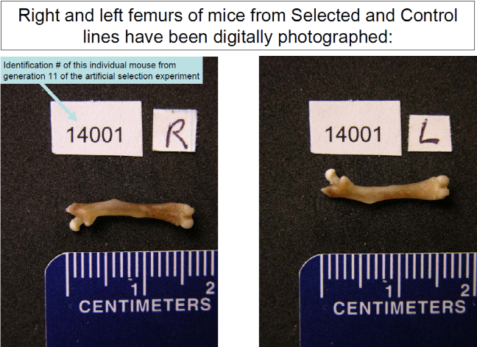 | These bones are from mice sampled from generation 11 of the selection experiment. Emphasize how animals from the selected lines run more than the controls by pointing out the generation on the graphs below.  The first graph shows data separately for the 4 replicate selected lines and the 4 non-selected control lines.  The second graph shows the average values for the selected and control lines, as well as the average difference between them.
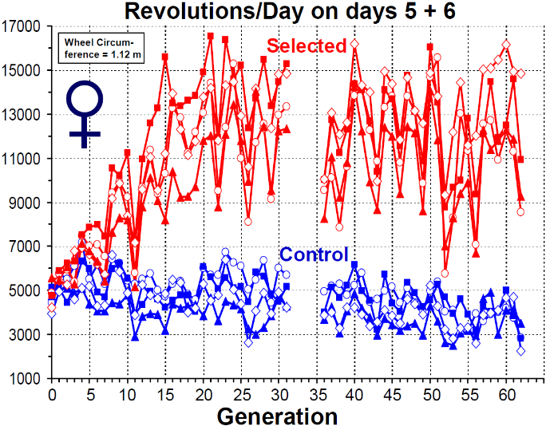 |  | 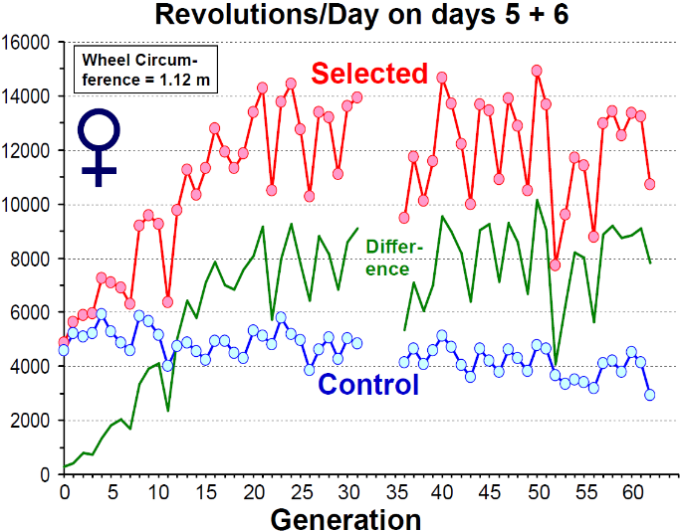
Developing a hypothesis: Prompt students to discuss the things which might be different in the legs of selected and control animals, and list them in part A of their lab handout. Students must then decide what they will measure on the femur pictures and record it in Part B of their lab handout. If students are working in groups, the decision must be made collaboratively. [Occasionally students will list changes in Part A which cannot be determined using the available samples. Remind them that they need to be able to measure something to be able to test this.] Then have students record their hypothesis using the “If...Then...” format.
Developing a method: Tell students to decide how they will be measuring the bones. Demonstrate measuring femoral length in different images using different landmark points. Ask if this would be a good way to collect data. What is wrong with it? How could you improve it?? Students will readily correct this technique. On their lab handout, have them indicate how they will measure the samples by drawing a line on the image.
Performing the measurements: Students can measure the samples in two different variations: automated, using Image J freeware and manual using direct measurement of images.
Preparation for automated measurements: Ensure that all student computers are preloaded with Image J and the folders containing selected and control samples. It avoids confusion to have separate folders for control and selected mice. If you have arranged for cross-curricular instruction, then have flash drives available to store the data collected.
Procedure for automated measurements: Refer students to the instructions for using Image J on their handout. Guide students through the steps. Demonstrate the technique on the teacher computer using a projector. Remind students to select summarize to display average measurements after finishing to display the averages. Image J files are saved as Excel files, so it is easy if you and your students choose to save the data for later analysis in math or computer classes. (See extensions and variations– cross-curricular options below.) Cautionary note: Students will not be able to use this feature if they measure both control and selected data sets together. The summarize feature averages all the samples in the data set.
Preparation for manual measurements: Print images (four per page works well). The images can be laminated for repeated use. Mark the back of each image so students can distinguish selected and control samples, as well as individual mice. Prepare a folder for each lab group containing images from selected and control animals. Have metric rulers and calculators available.
Procedure for manual measurements: Distribute manila folders containing a selection of printed images from both selected and control animals. Students can successfully measure 8 images each and then compile their results with those of three other students in their lab group. You can adjust this as necessary; however, it is unrealistic to assume that all the available photographs can be measured. If all the students have measured the same features (for example, femoral length), then the class data can be compiled.
Optional math extension for manual measurements: (see Extension section) Remind students that the measurements they have made do not represent actual lengths of the femurs. Compare an actual mouse femur with the image, either on an overhead projector or a doc cam. Ask students how they might use the measurement they made to calculate the actual size of the bone. Offer an extra credit option for students to calculate the actual sizes of the femurs. Ask students to defend the validity of using values that are not corrected for magnification in forming their conclusion.
EXPLAIN: Presenting the data and writing a conclusion.
Results and conclusion: Ask: What would be the best way to graph these results? [Students may quickly respond with “bar graph” – if students are struggling ask: Name some different kinds of graphs. Which would be the best kind to use to show the results from this investigation?] Use the Artificial Selection Lab Teacher PowerPoint to describe the required elements. Student groups graph their results on poster paper, white boards or overhead transparencies and share the results with the rest of the class. Frequently, multiple groups will measure leg length and get different results for selected and control groups. Lead discussions where the class analyzes why these differences might occur (e.g., sampling error).
Ask students to brainstorm what things would belong in a good conclusion. Gather the student answers and list them on a poster paper. Edit the list as a class and post it in the classroom for student reference as they write their conclusion piece. Alternative option: Review the Artificial Selection Lab Teacher PowerPoint panel describing the required elements for the conclusion.
ASSESSMENT: EVALUATE
Students lab reports serve as the summative assessment for this activity. A rubric for evaluating the lab reports and conclusion is included in Artificial Selection Lab Teacher Information.

EXTENSIONS and VARIATIONS:
Data Analysis Extensions:
Images of right and left femora of selected and control specimens from two different generations of mice are available for students to measure. Class discussions that take place immediately following Dr. Garland’s video might generate a variety of questions that could easily be evaluated by rearranging the images in the folders. For example,
- Sex differences by comparing male and female selected and control
- Differences in leg symmetry by comparing left and right bones of selected and control mice
- Differences in generations by comparing selected and control in two generations
Remind students that each of the specimens measured come from different mice, which have different body sizes. Can any differences be attributed to difference in body size? How might students correct for this? The body mass at death for each of the specimens is available in an Excel file (Listing_for_STEM_April_2012_without_Femur_Data.xls). Another version of this file includes the data for right and left femur lengths in mm, as used in the publication by Garland and Freeman (2005) (Listing_for_STEM_April_2012_with_Femur_Data.xls). Students can make graphs of femur length (Y axis) versus body mass (X axis).
Cross-curricular Options:
Some pre-planning with math and computer teachers might allow for students to integrate the graphing and data analysis portions of this lab into their other classes. Alternatively, you can address as many or as few of these issues while doing the lesson, depending on available time.
Graphing: Which is the best type of graph to display the data? Often students have difficulty choosing between the different types of graphs. Does the scale you chose show a true representation of the data or is it misleading?
Statistics: Is a difference significant? Often students think that any two numbers that are not identical represent an important difference. They are not aware that measurements are subject to error (e.g., human error, differences in image magnification, insufficient sample numbers).
Ratio and proportion: Manual measurement of printouts of the images yields measurements that are not corrected for magnification and will impact the results when differences are small. The scale bar in each picture allows students to use simple proportions to calculate actual sizes of the bones, and provides a math connection. In fact, there are slight differences in the magnification of each image. Have students measure the scale bar in successive images to see this for themselves. Ask how they might correct for this factor.
Computer use: Saving the data collected in Image J in Excel allows students to use the graphing features to generate and manipulate graphs to display differences. Using the function bar allows students to calculate averages, standard deviation, etc. Similar things can be done with the free spreadsheet on Google Drive.

RESOURCES:
- Video of selected and control mice running on wheels
http://www.youtube.com/watch?v=RuqhC7g_XP0
http://www.biology.ucr.edu/people/faculty/Garland/Girard01.mov
- Reinking, L. 2007. Image J Basics Biology 211 Laboratory Manual.
http://rsbweb.nih.gov/ij/docs/pdfs/ImageJ.pdf
- Information about Dr. Theodore Garland, Jr's. Research Lab
http://www.biology.ucr.edu/people/faculty/Garland.html
Relevant publications:
Garland, T., Jr., and P. A. Freeman. 2005. Selective breeding for high endurance running increases hindlimb symmetry. Evolution 59:1851-1854.
http://www.biology.ucr.edu/people/faculty/Garland/GarlandFreeman2005.pdf
Kelly, S. A., P. P. Czech, J. T. Wight, K. M. Blank, and T. Garland, Jr. 2006. Experimental evolution and phenotypic plasticity of hindlimb bones in high activity house mice. Journal of Morphology 267:360-374.
http://www.biology.ucr.edu/people/faculty/Garland/KellyEA2006.pdf
Middleton, K. M., S. A. Kelly, and T. Garland, Jr. 2008. Selective breeding as a tool to probe skeletal response to high voluntary locomotor activity in mice. Integrative and Comparative Biology 48:394-410.
http://www.biology.ucr.edu/people/faculty/Garland/Middleton_et_al_2008_ICB.pdf
Garland, T., Jr., and M. R. Rose, eds. 2009. Experimental evolution: concepts,
methods, and applications of selection experiments. University of California Press, Berkeley, California.
- Garland Public Lecture on "Born to Run: Evolution of Hyperactivity in Mice" 29 Oct. 2009 http://cnas.ucr.edu/sciencelectures/garlandlecture.html
- List of all publications in the High Runner lines of mice
http://biology.ucr.edu/people/faculty/Garland/Experimental_Evolution_Publications_by_Ted_Garland.html

EDUCATION STANDARDS MET WITH THIS LESSON:
NGSS: Next Generation Science Standards (2013): (Second Draft) Under Development
Nature of Science Matrix: “Scientific Knowledge is Based on Empirical Evidence”
Middle School Natural Selection & Adaptations: MS-LS4-a, d: Analyzing & Interpreting Data
High School Natural Selection and Evolution
HS-LS4-f: Design and conduct an investigation to find patterns in data indicating the relationship between changes in the environment and natural selection.
Framework for K-12 Science Education (2012) National Research Council:
LS4.B: Natural Selection: How does genetic variation among organisms affect survival and reproduction?
LS4.C: Adaptation: How does the environment influence populations of organisms over multiple generations?
California Science Education Standards (2003):
7th grade LS: Evolution: 3a,b; Structure and Function in Living Systems: 5c; 7th Grade Investigation and Experimentation: 7a,c,d,e
HS Biology/LS: Evolution 7a, 8a; HS Investigation and Experimentation: 1a, d, g
http://www.cde.ca.gov/be/st/ss/documents/sciencestnd.pdf
National Science Education Standards (1995):
UNIFYING CONCEPT: Evolution and equilibrium: The general idea that the present arises from materials and forms of the past.
SCIENCE AS INQUIRY: Ability to do scientific inquiry; Understandings about scientific inquiry
SCIENCE AND TECHNOLOGY: Abilities of technological design; Understandings about science and technology
CONTENT: Grades 5-8: 169: Life Science (content standard C): Diversity and adaptations of organisms
Biological Evolution accounts for diversity of species developed through gradual processes over many generations....
CONTENT: Grades 9-12: 192: Life Science (content standard C)
Biological Evolution (196): Species evolve over time. Evolution is the consequence of the interactions of ... http://www.csun.edu/science/ref/curriculum/reforms/nses/nses-complete.pdf

CREDITS: This work was supported by an NSF grant IOS-1121273 (Garland) and by an American Physiological Society Frontiers fellowship (Radojcic), with assistance from Dr. Heidi Schutz and the University of California, Riverside.

ATTRIBUTION:
Some of the ideas in this lesson may have been adapted from earlier, unacknowledged sources without our knowledge. If the reader believes this to be the case, then please let us know, and appropriate corrections will be made. Thank you.
1. Original Source: Theodore Garland, Jr., Ph.D. (University of California, Riverside)
2. Minor Editing for ENSIweb Format by: Larry Flammer
3. Reviewed by: Martin Nickels, Craig Nelson, Jean Beard: Jan. 2013

